* Add the Quick Launch Bar to the Taskbar in Windows 7

<http://www.howtogeek.com/howto/windows-7/add-the-quick-launch-bar-to-the-taskbar-in-windows-7/>

There is another way to do this.

1. Right-click on the taskbar and choose Toolbars > New Toolbar  
2. The new dialogue box will ask you to select a folder to be the new toolbar. You create a new folder (in the Libraries area, or on your C: drive root) and name it Quicklaunch.  
4. For any programs you want in the Quicklaunch bar, create shortcuts to those programs in your new Quicklaunch folder (wherever you created it) and they will appear in your Quicklunch toolbar.

Note: You won’t be able to click on this new tool bar until you put at least one shortcut into the folder.

Dans C:\DevLM j’ai créé un répertoire avec le nom « ------------------------------------------------  »  qui va agir comme séparateur. Des raccourcie clavier sont amener dans le répertoire « Quick Launch ».

* Run on line commands

Bouton <windows>+R

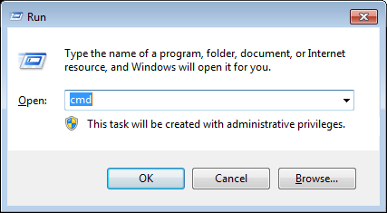

* abstract desktop wallpaper

<http://www.google.ca/search?q=desktop+wallpaper+1920+abstract&hl=en&prmd=imvns&tbm=isch&tbo=u&source=univ&sa=X&ei=g6hHUJauOuL10gHWzYGoCQ&ved=0CB8QsAQ&biw=1920&bih=928>

* Computer performance

Type cpu in

Control Panel\All Control Panel Items\System

Control Panel\All Control Panel Items\Performance Information and Tools

* Input Language

English (Canada) – Canadian French

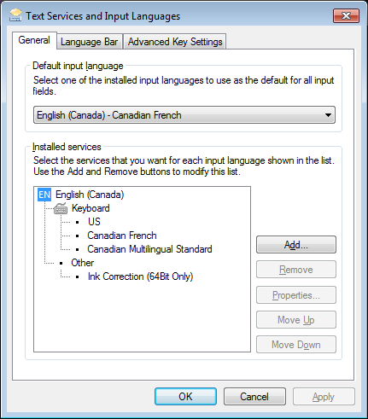

* Screens

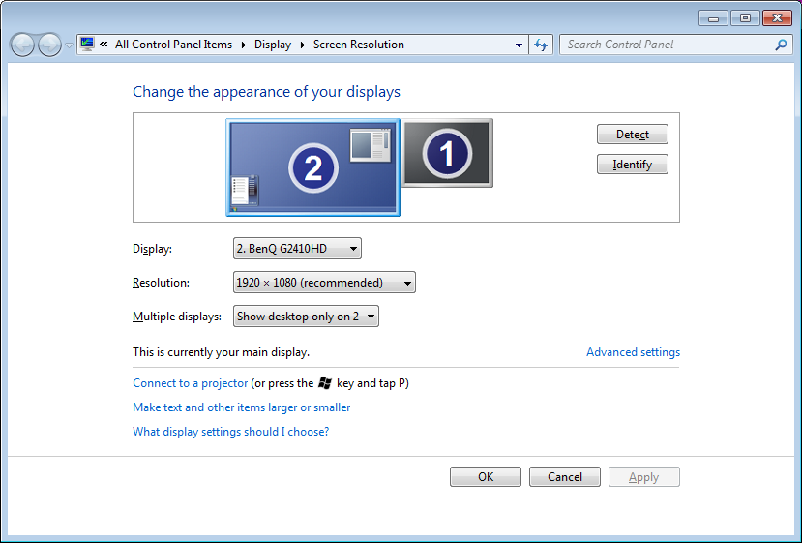

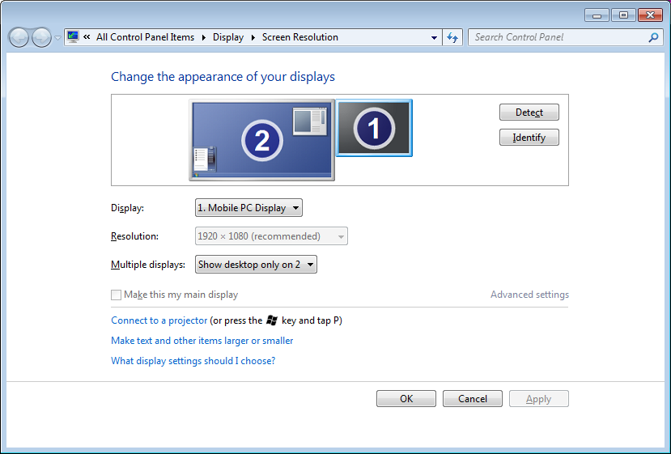

* New Tab Page – show, hide and customize top sites

<https://support.mozilla.org/en-US/kb/new-tab-page-show-hide-and-customize-top-sites>

If you are concerned about your privacy, you can turn this feature off completely:

In the Location bar, type about:config and press Enter.

The about:config "This might void your warranty!" warning page may appear. Click I'll be careful, I promise! to continue to the about:config page.

Type browser.newtab.url in the search box.

Double-click the browser.newtab.url preference and change the url from about:newtab to about:blank. Alternately, you can change it to about:home for the Firefox Google home page, or type in your preferred home page, for example google.com.

Click OK and close the about:config tab.

* Sss
* ss